

RFD900x Radio Modem Data Sheet

902-928MHz frequency band

Product Specifications and Performance

Flash Programmer User Manual

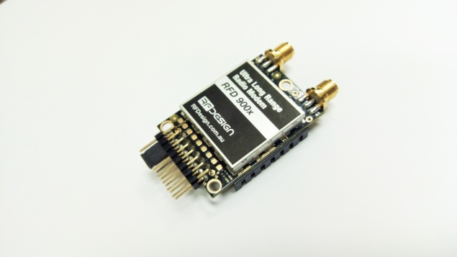

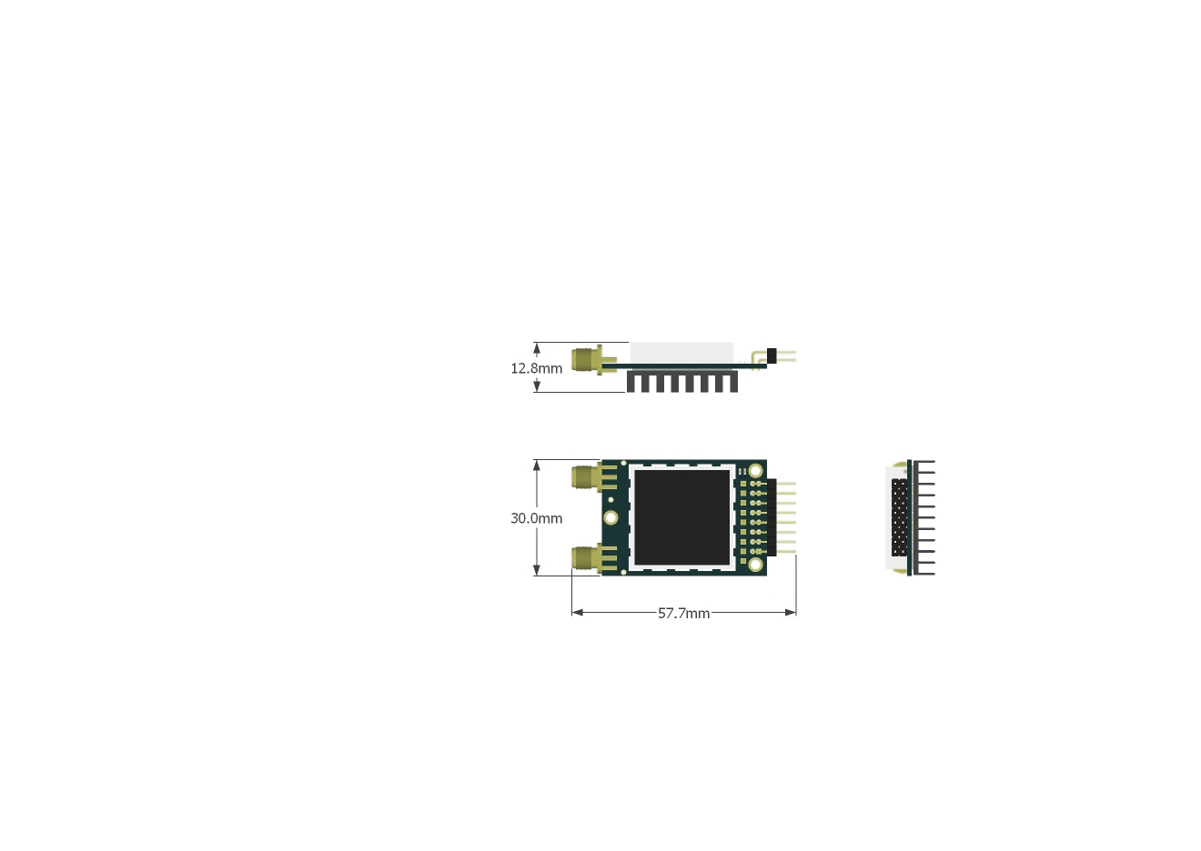

|  |  |  |
| --- | --- | --- |
| **Features**   * Out of the box RF communications. * Air data rate speeds of up to 500kbps * Diversity antenna support * Weight of 14g * Outdoor RF line-of-site range of 40km or more depending on antenna configuration   **Operational**   * Operating voltage: 5V, I/O Voltage (3.3V) * Temperature range: -40°C to +85°C * Dimensions of 30mm x 57.7mm x 12.8mm * Current consumption:   TX mode: ~1A peak at +30dBm,  RX mode: 60mA (typical) |  | **Applications**   * Telemetry data * UAV control * Remote weather station * House automation * Long range RC |
| RFDesign Pty Ltd  7/1 Stockwell Place  Archerfield, QLD 4108  rfdesign.com.au |

Table of contents

1 Key features 1

2 Specifications 3

3 Output power levels 4

4 Performance characteristics 5

5 Pin signals and layout 6

6 Physical dimensions 7

7 Software/GCS Support 8

8 Diversity 9

8.1 Spatial diversity 9

8.2 Polarisation diversity 9

9 Network options 10

9.1 Simple pair (P2P) 10

9.2 Multipoint network 10

9.3 Asynchronous non-hopping mesh 11

10 Frequently asked questions (FAQ) 12

How many antennas do I need to use? 12

How do I connect the FTDI cable to the modem? 12

What do I need to upload the firmware or to change the modem configuration? 12

What should I do if the Flash Programmer keeps displaying error messages? 12

I upgraded to multipoint firmware and the modems don't connect anymore? 12

How do I configure 2 base stations and one Airborne platform with 3 modems? 12

11 Useful links 14

12 Document revision history 15

# Key features

RFD900x provides compact and yet powerful data communication. The key features are:

* No configuration required for out of the box RF communications.
* Operating frequency range of 902 – 928MHz
* Outdoor RF line-of-site range of 40km or more depending on antennas
* Air data rate speeds of up to 250kbps
* Diversity antenna support
* Operating temperature of -40 to +85 degrees Celsius
* Dimensions of 30mm x 57mm x 12.8mm
* Weight of 14g

Compliances and Worldwide Acceptances:

The RFD900x is designed to be compliant to AS4268:2012, and FCC 15.247. It has not been certified as a standalone modem and should be compliance tested in the final product.

# Specifications

|  |  |
| --- | --- |
| Performance |  |
| Supported RF Data Rates | 4, 64, 125*, 250 and 500 kbps |
| Indoor Range | 500m – 1km |
| Line-Of-Sight Range | 40km or more depending on antennas |
| Transmit Power | 0 to 30dBm in 1dBm steps |
| Receiver Sensitivity | >121dBm at low data rates |
| Low Noise Amplifier | >20dB |

* can be set as 128 for compatibility

|  |  |
| --- | --- |
| Features |  |
| Serial Data Interface | +3.3V nominal, 3.3V tolerant |
| Configuration Method | AT Commands, APM Planner, Customised Configuration Tool |
| Frequency Band | 902MHz - 928MHz |
| Interference Immunity | FHSS (Frequency Hopping Spread Spectrum) |
| Serial Interface Data Rate | 2400, 4800, 9600, 19200, 38400, 57600, 115200, 460kbps |
| Antenna Connection | 2 x RPSMA diversity switched ports |
| GPIO | 6 pins (Digital, PPM capable) |
| Compliance Standards | FCC Part 15.247, AS/NZS 4268:2012 |

|  |  |
| --- | --- |
| Networking and Security |  |
| Addressing Options | Network ID: 0 –255 |
| Channels | Up to 50 Frequency Hopping Channels |
| Supported Network Topologies | Point-to-point, multipoint1, and asynchronous non-hopping mesh1 |

1 Only available in separate firmware versions available in the website

|  |  |
| --- | --- |
| Power Requirements |  |
| Supply Voltage | +5V nominal (+5V min, +5.5V Max, +6V ABS Max), |
| Transmit Current | ~1A peak at max power |
| Receive Current | ~60mA |

# Output power levels

Many countries have different legal power levels. Be sure to operate within the legal power limits of the country that you are operating in. The RFD900x modem can support the power levels between 0dBm and 30dBm in 1dBm steps. Formula 2-1 can be used to convert the power in dBm into milliwatts.

Formula 2-1

To calculate Effective Isotropic Radiated Power (EIRP) you can use the formula 2-2 below:

Formula 2-2

The FCC limit for EIRP is 4 Watts, or 36dBm for frequency hopping radios in the ISM 900 MHz band. The Australian EIRP limit is 30dBm as defined by ACMA.

# Performance characteristics

Figure 4-1 shows how the output power of the RFD900x varies with supply voltage when the output power is set to +30dBm.



Figure 4‑1:Ouput power vs. input supply voltage

Figure 4-2 shows how the current through the RFD900x varies with the transmit power level. The current during transmission is shown by the ‘High Level’ plot and that during receive mode is shown by the ‘Low Level’ plot.



Figure 4‑2: Current consumption vs. TX power level

# Pin signals and layout

|  |  |  |  |  |
| --- | --- | --- | --- | --- |
| Pin # | Name | Direction | Description | Max Voltage |
| 1 | GND | - | Ground | 0V |
| 2 | GND | - | Ground | 0V |
| 3 | CTS | Either | Clear to send | 3.3V |
| 4 | Vcc | - | Power supply | 3.3V |
| 5 | Vusb | - | Power supply from USB | 3.3V |
| 6 | Vusb | - | Power supply from USB | 3.3V |
| 7 | RX | Input | UART Data In | 3.3V |
| 8 | P3.4 | Either | Digital I/O | 3.3V |
| 9 | TX | Output | UART Data Out | 3.3V |
| 10 | P3.3 | Either | Digital I/O | 3.3V |
| 11 | RTS | Either | Request to send | 3.3V |
| 12 | P1.3 | Either | Digital I/O | 3.3V |
| 13 | P1.0 | Either | Digital I/O | 3.3V |
| 14 | P1.2 | Either | Digital I/O | 3.3V |
| 15 | P1.1 | Either | Digital I/O, PPM I/O | 3.3V |
| 16 | GND | - | Ground | 0V |

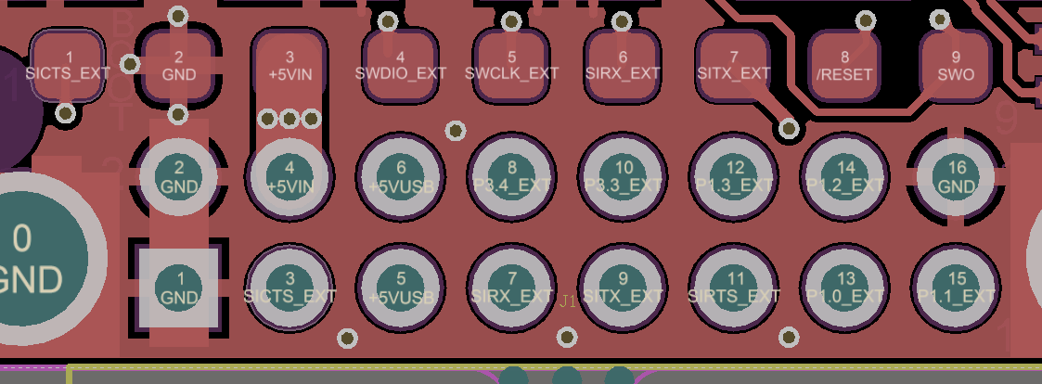

Figure 5‑1: Physical pin layout of the RFD900x Radio Modem

The FTDI cable (see “Useful Links”) is compatible with the RFD900x modem.

Pin 1 of the FTDI cable (black wire) should connect to pin 1 of the RFD900x header. In order to power the modem from the +5V USB power, a jumper is needed to connect pins 4 and 6.

To power the modem from an external +5V supply, connect the power to pins 2 and 4 as shown in figure 5-1.

In case there is a need to force the modem into boot mode, short circuit pad 9 (on the 9 way test pads) with pin 16 or GND while applying power. The on-board LED will become solid red when in boot mode.

# Physical dimensions

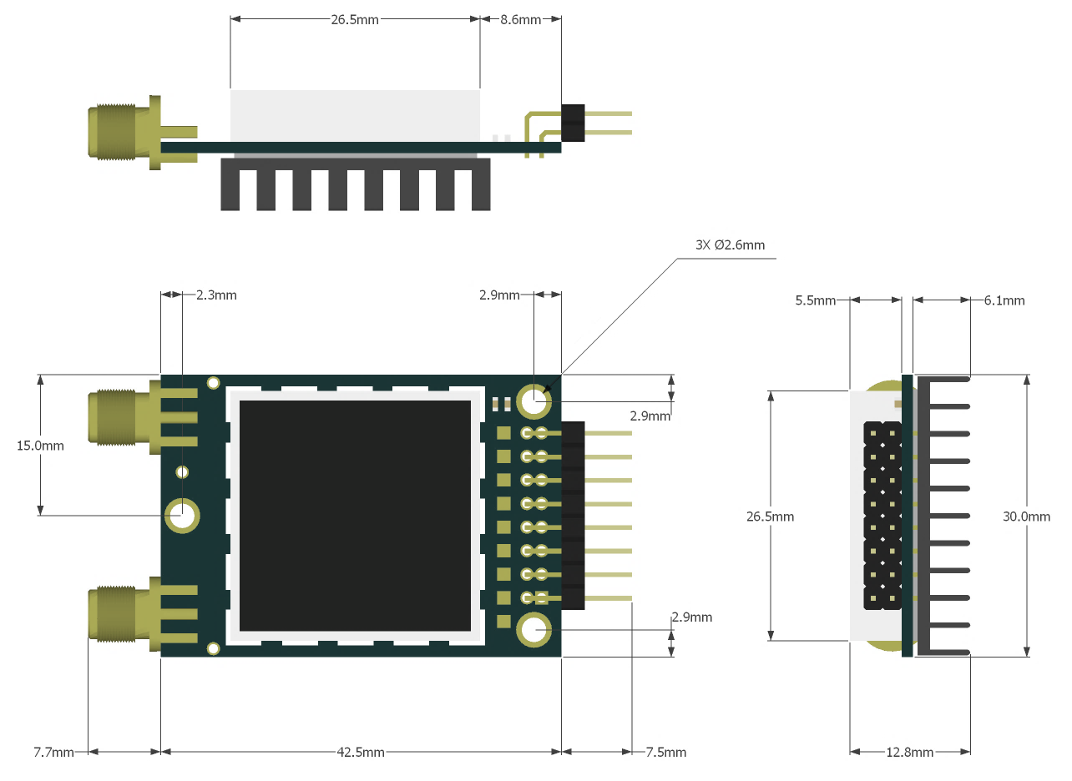

# Software/GCS Support

The software solution (see “Useful Links”) is an open source development which is called “SiK” and was created by Mike Smith and improved on by Andrew Tridgell and RFDesign.

A boot loader and interface is available using RFD900x Flash Programmer and field upgrade of the modem firmware via the serial port. The RFD900x modem features a boot loader which allows for the uploading of the various modem firmware via the serial port. This firmware upload is supported using the RFD900x Flash Programmer tool, current version of Mission Planner.

The RFD900x Radio Modem is compatible with many configuration methods like the AT Commands and APM Planner. The AT Commands can be used to change parameters such as power levels, air data rates, serial speeds, GPIO pins etc. Terminal programs such as hyperterminal or coolterm are useful for direct configuration of the modem via AT commands.

Integrated support for configuring the RFD900x Radio Modem is supported by the APM Planner, with other GCS solutions in development. Its default serial port settings are as follows:

* 57600 baud rate
* No parity
* 8 data bits
* 1 stop bit

The RFD900x Radio Modem has many software features including:

* Frequency Hopping Spread Spectrum
* Transparent Serial Link
* Configuration by simple AT commands for local radio, RT Commands for remote radio
* User configurable serial data rates and air data rates
* Error correction routines, MAVLink protocol framing (user selectable)
* MAVLink radio status reporting (Local RSSI, Remote RSSI, Local Noise, Remote Noise)
* Automatic antenna diversity switching on a packet basis in real-time
* Automatic duty cycle throttling based on radio temperature in order to avoid overheating
* PPM (R/C signal) pass through (Control vehicle across radio).

# Diversity

The RFD900x has two antenna ports and firmware which supports diversity operation of antennas. During the receive sequence the modem will check both antennas and select the antenna with the best receive signal. The antenna selected during receive is then also used for subsequent transmission. In the case of only one antenna connected, it will automatically select the port with the antenna connected. Testing by Silicon Labs has shown that link budgets can be improved up to the order of 8dB by employing a diversity scheme.

## Spatial diversity

Spatial diversity is the case where the antennas are separated by some distance from one another. It is recommended that two antennas connected to the RDF900 modem be separated by at least 25cm, more if possible.

## Polarisation diversity

Polarisation diversity is the case where the antennas are perpendicular to each other. i.e. one vertical, and one horizontal. This is effective in reducing multipath effects which affect one or the other polarisation. This scheme also helps to maintain the link between non-static objects such as aircraft performing acrobatics by increasing the likelihood that one antenna will maintain the same polarisation as an antenna on the other side of the link. Figure 8-1 depicts how two right-angle monopole antennas can be positioned to achieve polarisation diversity. This setup should ideally utilise a ground plane, but, it shown as an example utilising polarisation diversity.

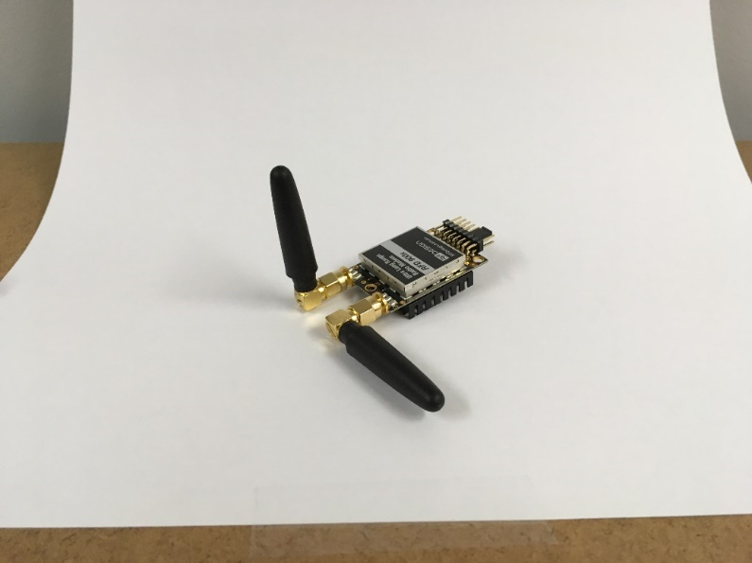

Figura 8-1: Antenna configuration to achieve polarisation diversity

# Network options

RFD900x can be implemented in either simple pair (P2P), multipoint network (MP Firmware Only), or asynchronous non-hopping mesh. The latter two are available for download in the website (see “Useful Links”).

## Simple pair (P2P)

The out-of-the-box firmware of the RFD900x radio modem is set to work in simple pair mode. If you purchased a bundle, you are only required to connect the antennas and supply to initiate the link. As soon as the pair synchronises, the on-board LED will become solid green.

**Node 1**

**Node 2**

Nodes within range

Figure 9‑1:Simple pair mode

## Multipoint network

This mode requires the Multipoint firmware to be loaded into the all network radios. Check section “Useful links” for the download link, and refer to section “RFD900x Flash Programmer tool” to flash the multipoint firmware. Refer to the “Multipoint user manual” for setup and usage instructions.

**Node 1**

SyncAny = 0

**Node 2**

**Node 3**

**Node 0**

Base

**Node 4**

SyncAny = 1

Within Node 1 range

Within Node 0 range

Figure 9‑2: example of multipoint network diagram

## Asynchronous non-hopping mesh

The asynchronous non-hopping mesh firmware offers a straight forward communication option that allows the user to quickly transmit and receive data across a great distance between two nodes or more. Figure 4-2 depicts this communication topology. As long as all the nodes are within range and have compatible parameters, communication between them will succeed.

Figure 9‑3: Asynchronous non-hopping mesh topology

**Node 1**

**Node 2**

**Node 3**

**Node 0**

**Node 4**

All nodes within range

# Frequently asked questions (FAQ)

## How many antennas do I need to use?

One is the minimum. Two is recommended.

## How do I connect the FTDI cable to the modem?

The black cable of the FTDI (pin 1) should connect to pin 1 on the modem as shown in Figure 10-1.

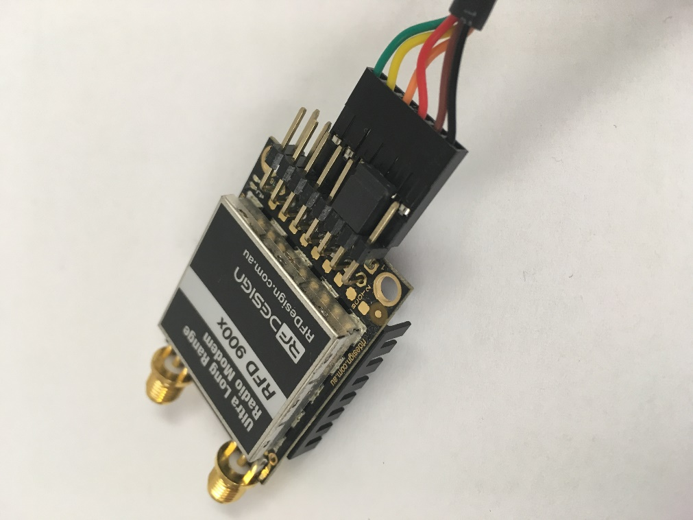

Figure 10‑1: An FTDI cable connected to the RFD900x modem

## What do I need to upload the firmware or to change the modem configuration?

Download the latest firmware (see “Useful Links”). Download the RFD900x Modem Tools (see “Useful Links”). Connect the FTDI cable to the modem and to a computer. Use the RFD900x Modem Tools to upload the latest firmware or to change the modem configuration (see “RFD900x Modem Tools User Manual”).

## What should I do if the Flash Programmer keeps displaying error messages?

Make sure to connect the FTDI cable firmly into the modem. Make sure you choose the correct COM port from the COM dropdown box and the correct baud rate. Try for two more trials and if it still doesn’t work, disconnect and reconnect the modem. Should it still fail open a terminal programme and perform a loop back test on the cable. Short the orange and yellow pins of the FTDI cable with something like a paper clip. Then using the terminal programme connect to the COM of the cable then type some text if this text is not returned then it indicates there is likely a fault with the FTDI cable where possible retry the upload process with a new cable.

## I upgraded to multipoint firmware and the modems don't connect anymore?

The default setting for a modem is to have a NODEID set to 1. A network must have one node set to 0 to be the base. The base node defines the synchronisation for the whole network of nodes.

## How do I configure 2 base stations and one Airborne platform with 3 modems?

Set the Airborne platform as follows:

NODEID = 0

NODEDESTINATION = 65535

MAVLINK = 1

Set the ground station as follows:

NODEID = 1 or 2

NODEDESTINATION = 0

MAVLINK = 1

This will allow the airborne modem to handover to multiple ground stations as it flies from the coverage area of one ground station, to another. Both ground stations can be connected and can control the Airborne platform simultaneously. (APM Planner using MAVLink)

# Useful links

RFD900x Firmware

<http://rfdesign.com.au/firmware/>

RFD SiK firmware is standard SiK (open source)

RFD Multipoint firmware is multipoint SiK (MP SiK)

RFD900x Flash Programmer

<http://rfdesign.com.au/downloads/>

FTDI Cable documentation

<http://www.ftdichip.com/Support/Documents/DataSheets/Cables/DS_TTL-232R_CABLES.pdf>

# Document revision history

|  |  |  |
| --- | --- | --- |
| Version | Date | Changes |
| 1.0 |  | Release document |